Exercise 1: Logging Error Messages and Warning Levels
Task:
Write a Java application that demonstrates logging error messages and warning levels using SLF4J.
1.Add SLF4J and Logback dependencies to `pom.xml` file:
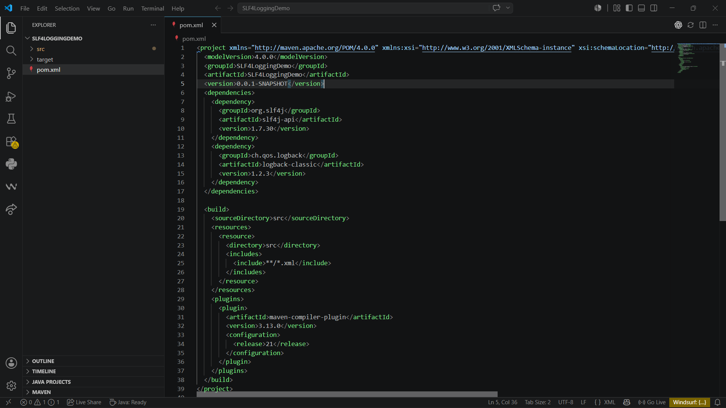
2. Create a Java class that uses SLF4J for logging:
LoggingExample.java:
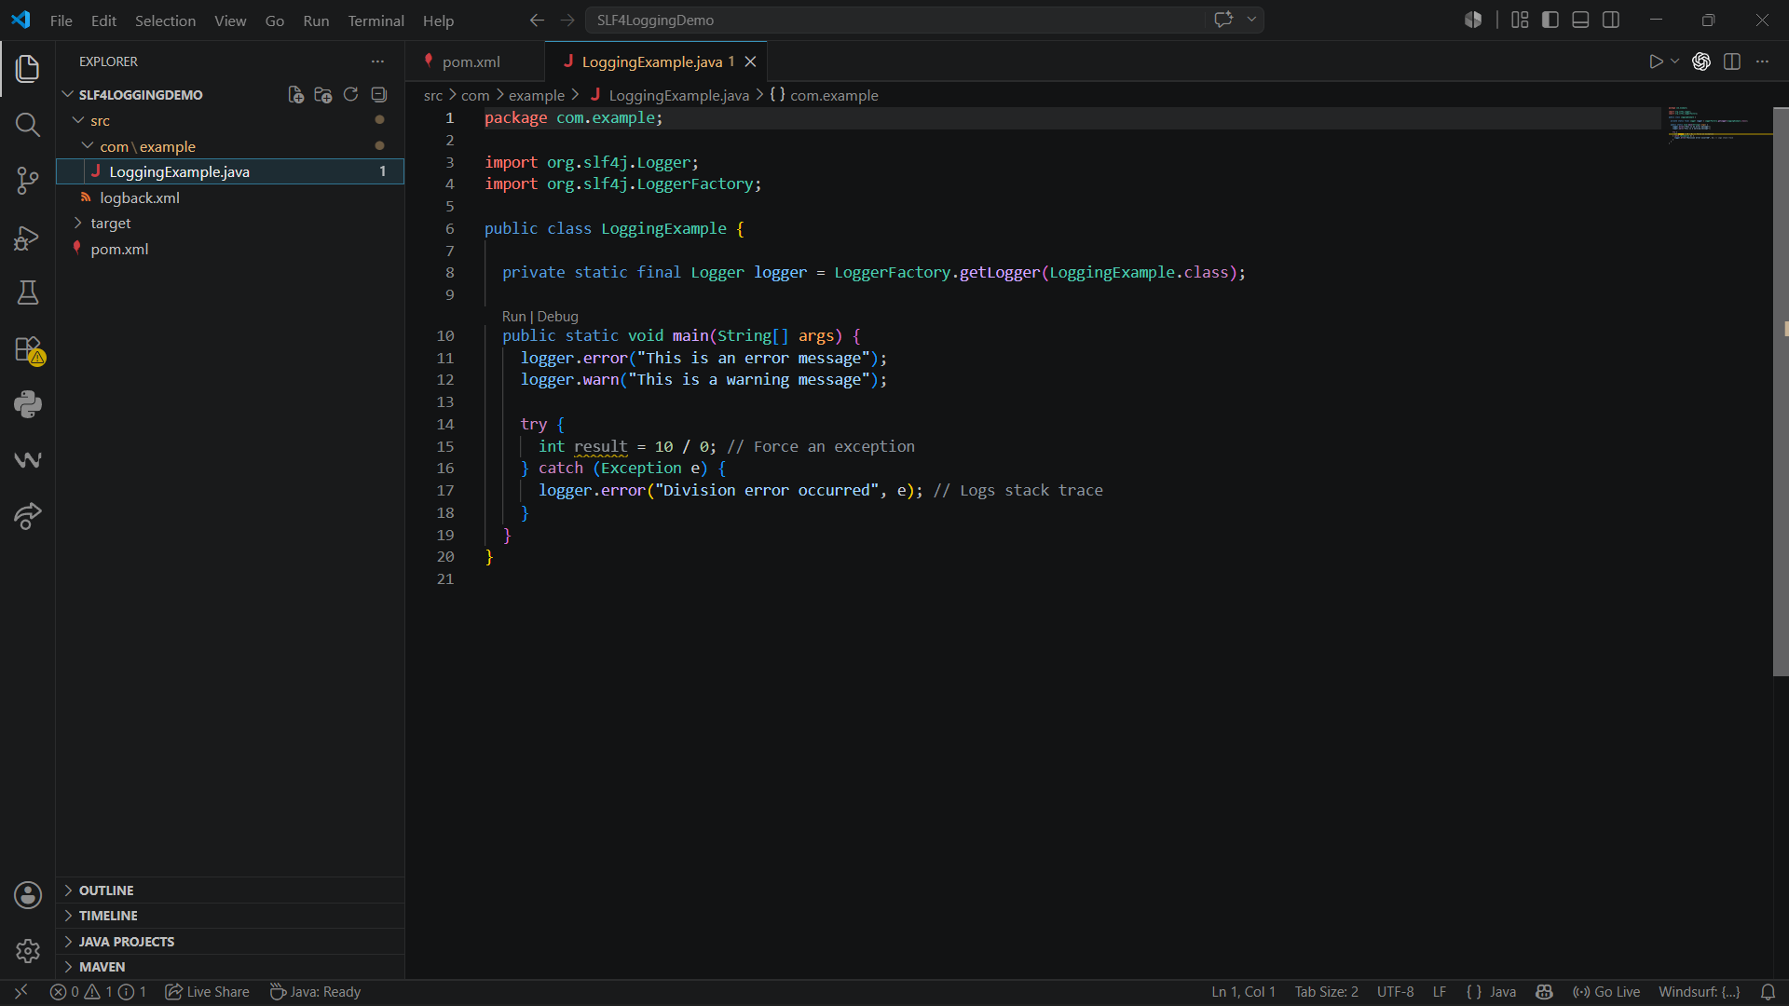
Output:
